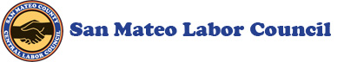
Brothers & Sisters,
Governor Newsom announced a new "Regional Stay Home Order" for regions with less than 15% intensive care unit capacity. The Bay Area is not immediately impacted but the state projects that we could fall below the 15% threshold by mid-to-late-December. Once triggered, the order would be in effect for three weeks and would prohibit private gatherings of any size and close or impose capacity restrictions at many businesses except for critical infrastructure.
Read the full News Release HERE.
Thank you,
Susan Charles, Office Manager
San Mateo County Central Labor Council
(650) 572-8848

